# Lab: Conditional Statements Advanced

Problems for exercise and homework for the "**Programming Basics**" course [@ SoftUni Global](https://softuni.org).

Submit your solutions in the SoftUni Judge system at: <https://judge.softuni.org/Contests/Compete/Index/3544>

## Day of Week

Write a program that reads an **integer** entered by the user and prints a **day of the week** within [1 ... 7] or prints "**Error**" if the number entered is **invalid**.

### Sample Input and Output

|  |  |
| --- | --- |
| **Input** | **Output** |
| 1 | Monday |
| 2 | Tuesday |
| 3 | Wednesday |
| 4 | Thursday |
| 5 | Friday |
| 6 | Saturday |
| 7 | Sunday |
| -1 | Error |

### Hints and Guidelines

1. Create a **new** class in an existing IntelliJ project. Right-click on the **'src'** folder. Select [New] 🡪 [Class]:

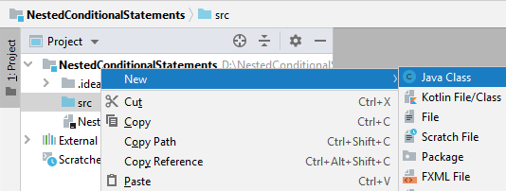🡺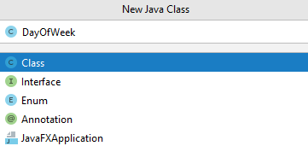

You already have a project with one console application in it. It remains to write the code to solve the problem.

1. Create a main method and write the solution of the problem. You can help yourself with the code from the pictures below:

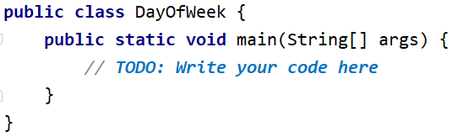

1. Read an integer from the console:

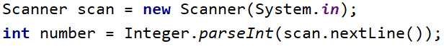

1. Print the day of the week according to the number entered. If it is invalid, print "**Error**".

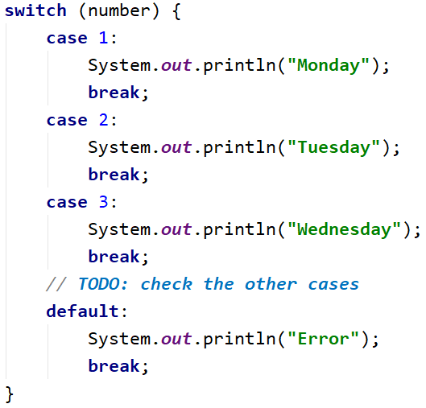

### Testing in the Judge System

Test the solution to this problem here: <https://judge.softuni.org/Contests/Compete/Index/3544#0>

## Weekend or Working Day

Write a program that reads the day of the week (**string**) - entered by the user. If the day is a working day, it prints on the console - "**Working day**", if it is a day off - "**Weekend**". If any text other than the day of the week is entered, print "**Error**".

### Sample Input and Output

|  |  |
| --- | --- |
| **Input** | **Output** |
| Monday | Working day |

|  |  |
| --- | --- |
| **Input** | **Output** |
| Sunday | Weekend |

|  |  |
| --- | --- |
| **Input** | **Output** |
| April | Error |

### Hints and Guidelines

1. Read the day of the week (**string**) from the console:

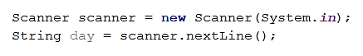

1. Print a working day or day off, depending on the day you entered. If the day is invalid, print it "**Error**":

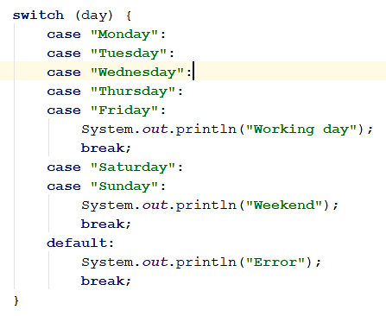

### Testing in the Judge System

Test the solution to this problem here: <https://judge.softuni.org/Contests/Compete/Index/3544#1>

## Animal Type

Write a program that prints the species of the animal according to its name entered by the user.

* dog **->** mammal
* crocodile**,** tortoise**,** snake **->** reptile
* others **->** unknown

### Sample Input and Output

|  |  |
| --- | --- |
| **Input** | **Output** |
| dog | mammal |
| snake | reptile |
| cat | unknown |

### Hints and Guidelines

1. Read the input:

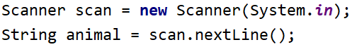

1. Check the specie. If it is invalid, print "**unknown**".

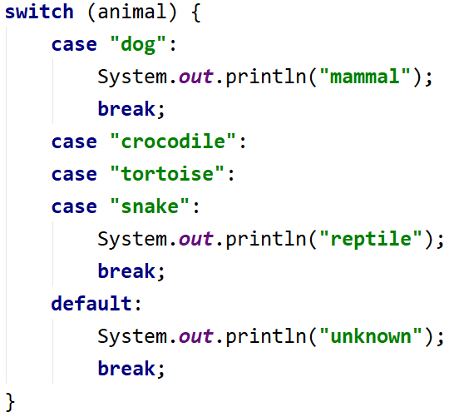

### Testing in the Judge System

Test the solution to this problem here: <https://judge.softuni.org/Contests/Compete/Index/3544#2>

## Personal Titles

Write a console program that reads the **age** (a floating-point number) and **gender** ("m" or "f") entered by the user and prints an address from the following:

* "Mr." - a man (gender "m") of 16 years or more
* "Master" - a boy (gender "m") under 16 years old
* "**Ms.**" – a woman (gender "f") of 16 years or more
* "**Miss**" – a girl (gender "f") under 16 years old

### Sample Input and Output

|  |  |  |  |  |  |  |  |  |  |  |
| --- | --- | --- | --- | --- | --- | --- | --- | --- | --- | --- |
| **Input** | **Output** |  | **Input** | **Output** |  | **Input** | **Output** |  | **Input** | **Output** |
| 12  f | Miss | 17  m | Mr. | 25  f | Ms. | 13.5  m | Master |

### Hints and Guidelines

1. Read the input from the console. First read a **floating-point number**, "**age**", and the next line a **string** for "**gender**".

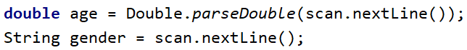

1. Perform a gender check using the "**equals**" method, with a "**true**" result, and make a conditional statement for the age and print the desired message on the console.

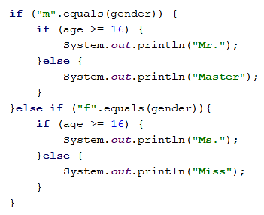

1. **Start** the program with [Ctrl + Shift + F10] and **test** it with different input values:

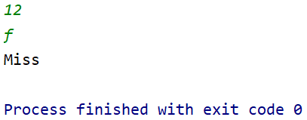 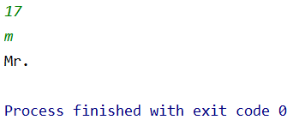

1. You must receive **100 points** (completely correct solution):

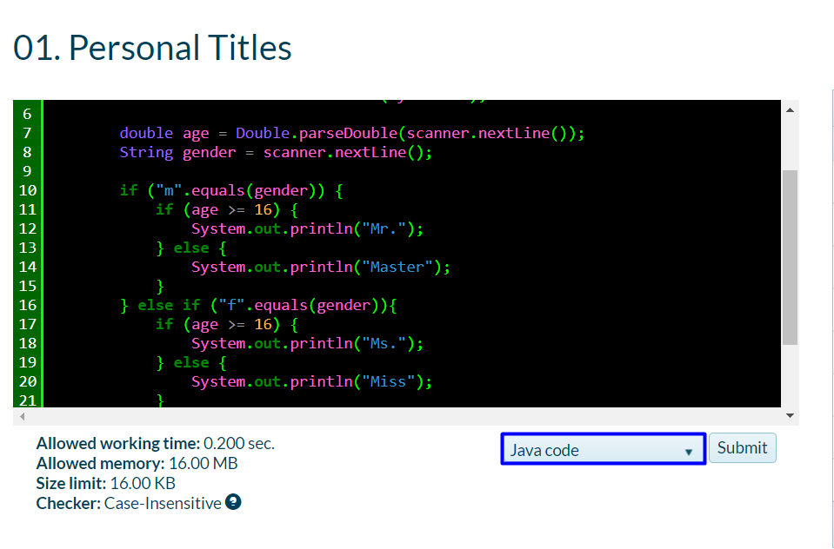

### Testing in the Judge System

Test the solution to this problem here: <https://judge.softuni.org/Contests/Compete/Index/3544#3>

## Small Shop

An enterprising person opens **neighborhood shops** in **several cities** and sells at **different prices**:

|  |  |  |  |  |  |
| --- | --- | --- | --- | --- | --- |
| city / product | **coffee** | **water** | **beer** | **sweets** | **peanuts** |
| **London** | 0.50 | 0.80 | 1.20 | 1.45 | 1.60 |
| **Rome** | 0.40 | 0.70 | 1.15 | 1.30 | 1.50 |
| **Paris** | 0.45 | 0.70 | 1.10 | 1.35 | 1.55 |

Write a program that reads **product** (string), **city** (string), and **quantity** (a floating-point number) entered by the user and calculates and prints **how much** the corresponding quantity of the selected product costs in the specified city.

### Sample Input and Output

|  |  |  |  |  |  |  |  |  |  |  |  |  |  |
| --- | --- | --- | --- | --- | --- | --- | --- | --- | --- | --- | --- | --- | --- |
| **Input** | **Output** |  | **Input** | **Output** |  | **Input** | **Output** |  | **Input** | **Output** |  | **Input** | **Output** |
| coffee  Paris  2 | 0.9 | peanuts  Rome  1 | 1.5 | beer  London  3 | 3.6 | water  Rome  2 | 1.4 | sweets  London  2.23 | 3.2335 |

### Testing in the Judge System

Test the solution to this problem here: <https://judge.softuni.org/Contests/Compete/Index/3544#4>

## Number in Range

Write a program that checks if the number entered by the user is in the range [-100, 100] and is different from 0 and print "**Yes**" if it meets the conditions, or "**No**" if it is outside the range.

### Sample Input and Output

|  |  |  |  |  |  |  |  |
| --- | --- | --- | --- | --- | --- | --- | --- |
| **Input** | **Output** |  | **Input** | **Output** |  | **Input** | **Output** |
| -25 | Yes | 0 | No | 25 | Yes |

### Testing in the Judge System

Test the solution to this problem here: <https://judge.softuni.org/Contests/Compete/Index/3544#5>

## Working Hours

Write a program that reads an hour of the day (**integer**) and a day of the week (**string**) - entered by the user and checks whether the company's office is open, the office hours are from **10**:**00**(10 am) to **18:00**(6 pm), from **Monday** to **Saturday** including.

### Sample Input and Output

|  |  |  |  |  |  |  |  |
| --- | --- | --- | --- | --- | --- | --- | --- |
| **Input** | **Output** |  | **Input** | **Output** |  | **Input** | **Output** |
| 11  Monday | open | 19  Friday | closed | 11  Sunday | closed |

### Testing in the Judge System

Test the solution to this problem here: <https://judge.softuni.org/Contests/Compete/Index/3544#6>

## Cinema Ticket

Write a program that reads the day of the week (**string**) - entered by the user and prints on the console the price of a movie ticket according to the day of the week:

|  |  |  |  |  |  |  |
| --- | --- | --- | --- | --- | --- | --- |
| **Monday** | **Tuesday** | **Wednesday** | **Thursday** | **Friday** | **Saturday** | **Sunday** |
| 12 | 12 | 14 | 14 | 12 | 16 | 16 |

### Sample Input and Output

|  |  |  |  |  |  |  |  |
| --- | --- | --- | --- | --- | --- | --- | --- |
| **Input** | **Output** |  | **Input** | **Output** |  | **Input** | **Output** |
| Monday | 12 | Friday | 12 | Sunday | 16 |

### Testing in the Judge System

Test the solution to this problem here: <https://judge.softuni.org/Contests/Compete/Index/3544#7>

## Fruit or Vegetable

Write a program that reads a **product name** entered by the user and checks if it is a **fruit** or **vegetable**.

* The fruits are **banana**, **apple**, **kiwi**, **cherry**, **lemon,** and **grapes**
* The vegetables "**vegetable**" are **tomato**, **cucumber**, **pepper,** and **carrot**
* Everything else is "**unknown**"

Print "**fruit**", "**vegetable**" or "**unknown**" depending to the introduced product.

### Sample Input and Output

|  |  |  |  |  |  |  |  |  |  |  |
| --- | --- | --- | --- | --- | --- | --- | --- | --- | --- | --- |
| **Input** | **Output** |  | **Input** | **Output** |  | **Input** | **Output** |  | **Input** | **Output** |
| banana | fruit | apple | fruit | tomato | vegetable | water | unknown |

### Testing in the Judge System

Test the solution to this problem here: <https://judge.softuni.org/Contests/Compete/Index/3544#8>

## Invalid Number

A **number is valid** if it is in the range [**100… 200**] or is **0**. Write a program that reads an **integer** entered by the user and print "**invalid**" if the number entered **is not valid**.

### Sample Input and Output

|  |  |  |  |  |  |  |  |  |  |  |
| --- | --- | --- | --- | --- | --- | --- | --- | --- | --- | --- |
| **Input** | **Output** |  | **Input** | **Output** |  | **Input** | **Output** |  | **Input** | **Output** |
| 75 | invalid | 150 | *(no output)* | 220 | invalid | 199 | *(no output)* |

|  |  |  |  |  |  |  |  |  |  |  |
| --- | --- | --- | --- | --- | --- | --- | --- | --- | --- | --- |
| **Input** | **Output** |  | **Input** | **Output** |  | **Input** | **Output** |  | **Input** | **Output** |
| -1 | invalid | 100 | *(no output)* | 200 | *(no output)* | 0 | *(no output)* |

### Testing in the Judge System

Test the solution to this problem here: <https://judge.softuni.org/Contests/Compete/Index/3544#9>

## Fruit Shop

Fruit shop on **weekdays** works at the following **prices**:

|  |  |  |  |  |  |  |  |
| --- | --- | --- | --- | --- | --- | --- | --- |
| **fruit** | **banana** | **apple** | **orange** | **grapefruit** | **kiwi** | **pineapple** | **grapes** |
| **price** | 2.50 | 1.20 | 0.85 | 1.45 | 2.70 | 5.50 | 3.85 |

On **Saturdays** and **Sundays**, the store is works at higher **prices**:

|  |  |  |  |  |  |  |  |
| --- | --- | --- | --- | --- | --- | --- | --- |
| **fruit** | **banana** | **apple** | **orange** | **grapefruit** | **kiwi** | **pineapple** | **grapes** |
| **price** | 2.70 | 1.25 | 0.90 | 1.60 | 3.00 | 5.60 | 4.20 |

Write a program that reads from the console **fruit** (banana / apple / orange / grapefruit / kiwi / pineapple / grapes), **day of the week** (Monday / Tuesday / Wednesday / Thursday / Friday / Saturday / Sunday), and **quantity** (a floating-point number), entered from the customer, and calculates the sum according to the **prices** in the tables above. In case of an invalid day of the week or invalid fruit name, print "**error**".

### Sample Input and Output

|  |  |  |  |  |  |  |  |  |  |  |  |  |  |
| --- | --- | --- | --- | --- | --- | --- | --- | --- | --- | --- | --- | --- | --- |
| **Input** | **Output** |  | **Input** | **Output** |  | **Input** | **Output** |  | **Input** | **Output** |  | **Input** | **Output** |
| apple  Tuesday  2 | 2.40 | orange  Sunday  3 | 2.70 | kiwi  Monday  2.5 | 6.75 | grapes  Saturday  0.5 | 2.10 | tomato  Monday  0.5 | error |

### Testing in the Judge System

Test the solution to this problem here: <https://judge.softuni.org/Contests/Compete/Index/3544#10>

## Trade Commissions

The company gives the following **commissions** to its merchants according to the **city** in which they operate and the volume of sales:

|  |  |  |  |  |
| --- | --- | --- | --- | --- |
| **City** | **0 ≤ s ≤ 500** | **500 < s ≤ 1 000** | **1 000 < s ≤ 10 000** | **s > 10 000** |
| London | 5% | 7% | 8% | 12% |
| Paris | 4.5% | 7.5% | 10% | 13% |
| Rome | 5.5% | 8% | 12% | 14.5% |

Write a **console program** that reads the city name (**string**) and sales volume (**a floating-point number**) entered by the user and calculates the percentage of the trade commission according to the table above. Display the result formatted to 2 digits after the decimal point. In case of **invalid** city or sales volume (negative number) print "**error**".

### Sample Input and Output

|  |  |  |  |  |  |  |  |  |  |  |
| --- | --- | --- | --- | --- | --- | --- | --- | --- | --- | --- |
| **Input** | **Output** |  | **Input** | **Output** |  | **Input** | **Output** |  | **Input** | **Output** |
| London 1500 | 120.00 | Rome 499.99 | 27.50 | Paris 3874.50 | 387.45 | InvalidName  -50 | error |

### Testing in the Judge System

Test the solution to this problem here: <https://judge.softuni.org/Contests/Compete/Index/3544#11>